Order Received-Shipped or Donated

Here is what you need to know about orders your Girl Scouts might have received.

Shipped/Donated orders:

In eBudde you can look on the Girl Orders tab to see how many boxes each girl has sold. You do not need to provide any inventory to her for those orders.
You will see a credit for the full amount paid for those orders.

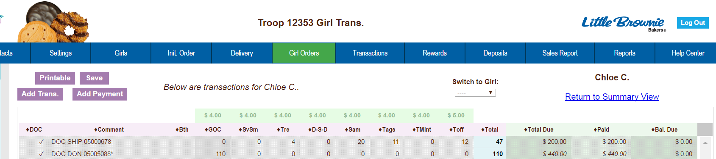
Amount Paid
Number of boxes

Shipped Order

All Digital Cookie sales will add to your troop’s total cookies sold and each girl’s total cookies sold. They will be reflected in your Sales and Per Girl Average and count towards any rewards the girl may be eligible to receive.



You can also see the amount as a Deposit in your Deposits tab in eBudde.

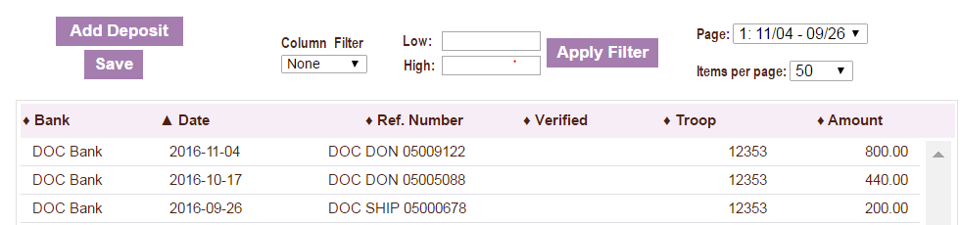


You may need to adjust the amount of money you deposit using the sales report as a guide. OR If your council has ACH withdrawals they will adjust to reflect a deposit already being made into your account.

DOC Ship/Donate orders reflect in “Pkgs Received”

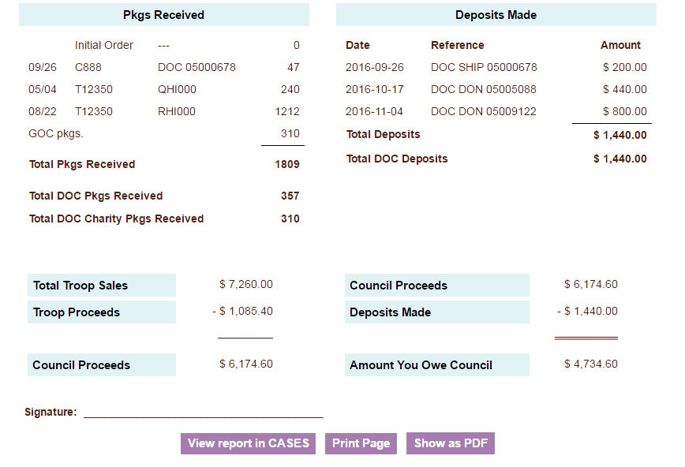
DOC Ship/Donate orders reflect in “Deposits Made”

